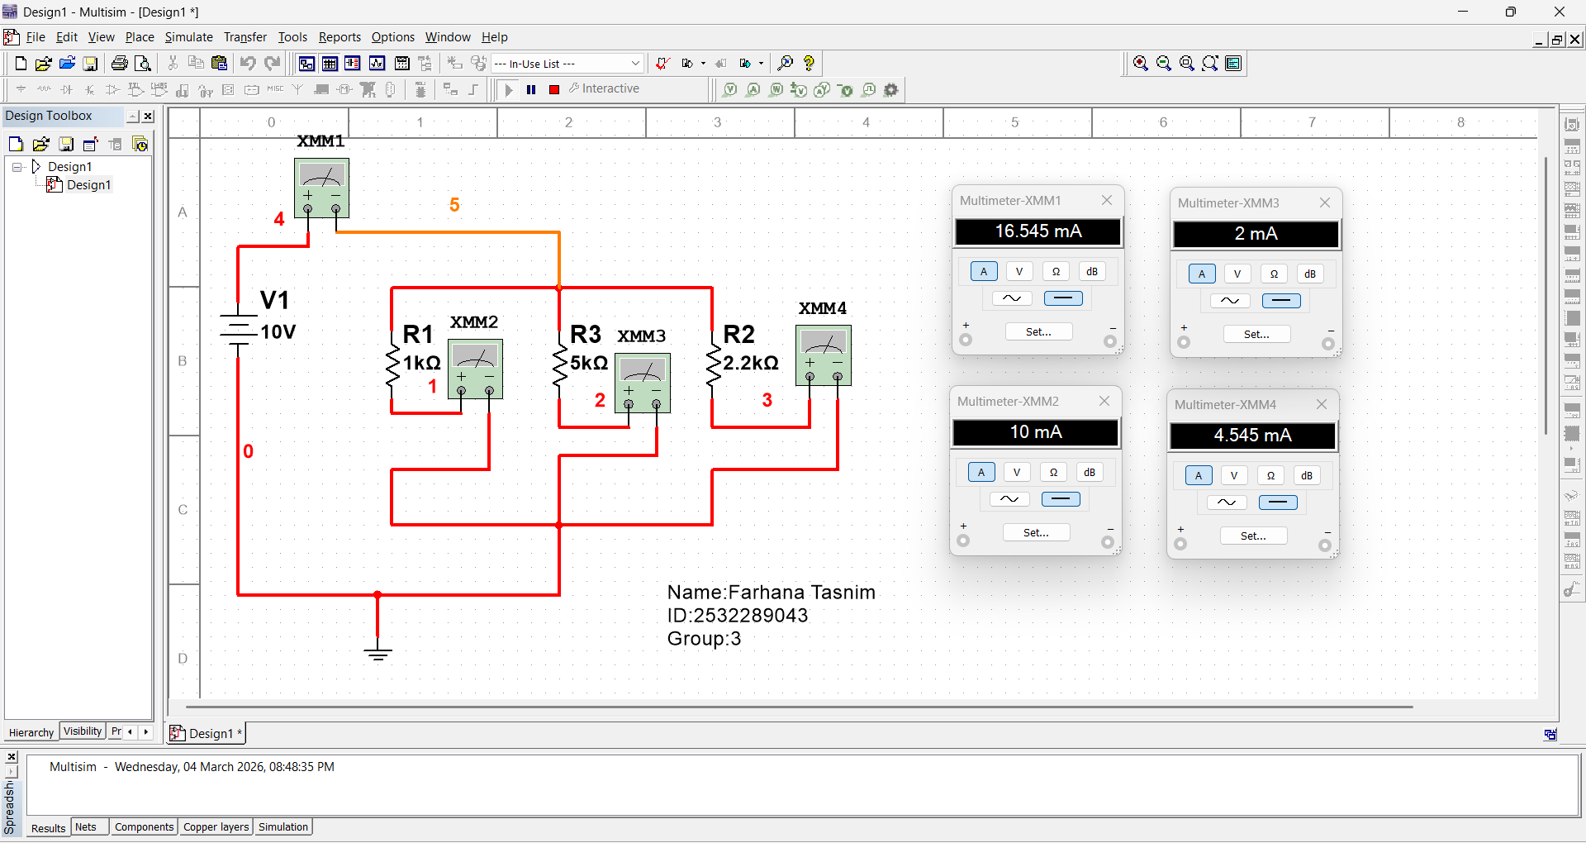
Name:Farhana Tasnim
ID: 2532289043 Group:3

